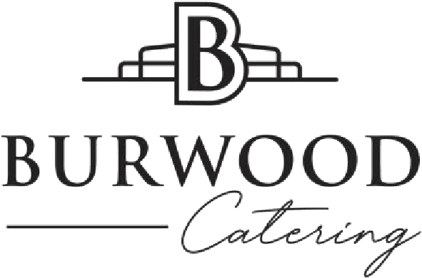

At The Burwood Inn, we aim to make every event the best yet, and we commit the same time, effort and quality when we cater for any occasion at other locations.
We can help you chose the most suitable options and quantities, and advise on anything else you might need, whether you are planning a special private event or a corporate get together.
We have a comprehensive list of delicious food options and are flexible where possible to adjust to your individual needs.
The following dishes are available for events at The Burwood Inn or for external caterings.
A minimum food order of $ 500 applies to all external options or to reserve an area in the lounge at The Burwood Inn.

CANAPES AND FINGER FOOD
Cheese & garlic pizza bread (v) 24pc $ 36
Shucked Karuah River oysters (gf,df) 12pc $ 48
Barbeque pork ribs (gf, df) 25pc $ 75
Cured salmon, ricotta & cucumber bites (gf, df) 25pc $ 75
Beetroot & labna cheese tartlets (v) 25pc $ 75
Southern fried cauliflower w/ harissa mayo (vgn) 25pc $ 75
Pumpkin arancini w/ rocket aioli (v) 25pc $ 80
Fried chicken wings w/ chilli mayonnaise (gf, df) 25pc $ 80
Satay chicken skewers (gf, df) 25pc $ 80
Pulled pork sliders, chipotle sauce 25pc $ 100
Southern fried mushroom sliders, chilli mayonnaise (v) 25pc $ 100
Selection of pizzas 5pc $ 100

GRAZING STATIONS
Chef’s selection of local & imported cheeses $15/person
Chef’s selection of 3 housemade mini sandwiches $15/person
Chef’s selection of charcuterie & cold cuts $20/person

vgn=vegan | v=vegetarian |gf=gluten free |gfo=gluten free option available | df=dairy free

BANQUET DINNER
Banquets are rapidly becoming a popular option for sit-down events, creating a relaxed family dinner atmosphere where guests interact whilst sharing a gorgeous meal.
This makes the below options a perfect choice for work events, dinner parties and wedding catering. We offer the following choices for groups of more than 10 guests in our restaurant or for 20 or more guests for external caterings.
2 course Banquet menu $ 60 per person
3 course Banquet menu $ 75 per person

ENTRÉE – SHARED CANAPES (CHOOSE 3)
- Shucked Karuah River oysters (gf, df)
- Cured salmon, ricotta & cucumber bites (gf, df)
- Barbeque pork ribs (gf, df)
- Pumpkin Arancini, Rocket Aioli (v)
- Fried chicken wings, Chilli Mayonnaise (df, gf)
- Southern fried cauliflower w/ harissa mayo (vgn)
- Beetroot & Labna Cheese Tartlets (v)

MAIN COURSE (CHOOSE 2)
- Whole roasted scotch fillet w/ port jus (gf)
- Roasted BBQ chicken in house blend of herbs & spices (gf)
- Pork knuckles braised in black grape & balsamic sauce (gf, df)
- Whole roasted NZ Snapper in lemon & herb butter (gf)
- Whole braised lamb shoulder w/ jus gras (gf)
- Grilled eggplant & lentil salad w/ harissa mayonnaise (gf, vgn)

SIDES (CHOOSE 3)
- Mashed potato & gravy (v)
- Garden salad & cider vinaigrette (vgn, gf)
- Green beans in garlic butter (gf)
- Fries & aioli (gf)

DESSERT (ALTERNATE DROP)
- Hazelnut praline w/ chocolate mousse & orange coulis (gf)
- Lemon curd tart w/ raspberry coulis, dried meringue & pistachio crumb
or
CHEF’S SELECTION OF LOCAL & IMPORTED CHEESES
- Served with fresh fruit & preserves

